# CS 255 System Design Document Template

## UML Diagrams

### UML Use Case Diagram

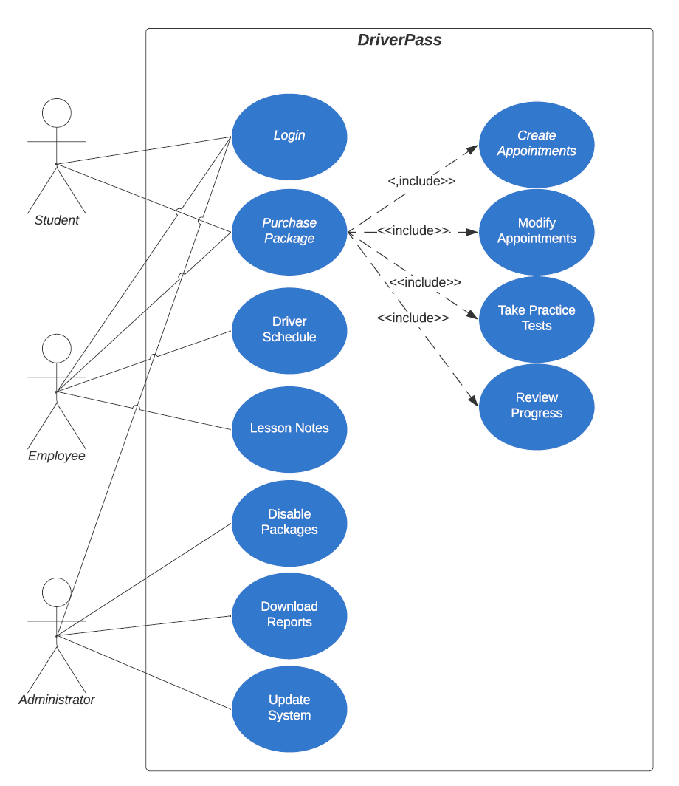

### UML Activity Diagrams

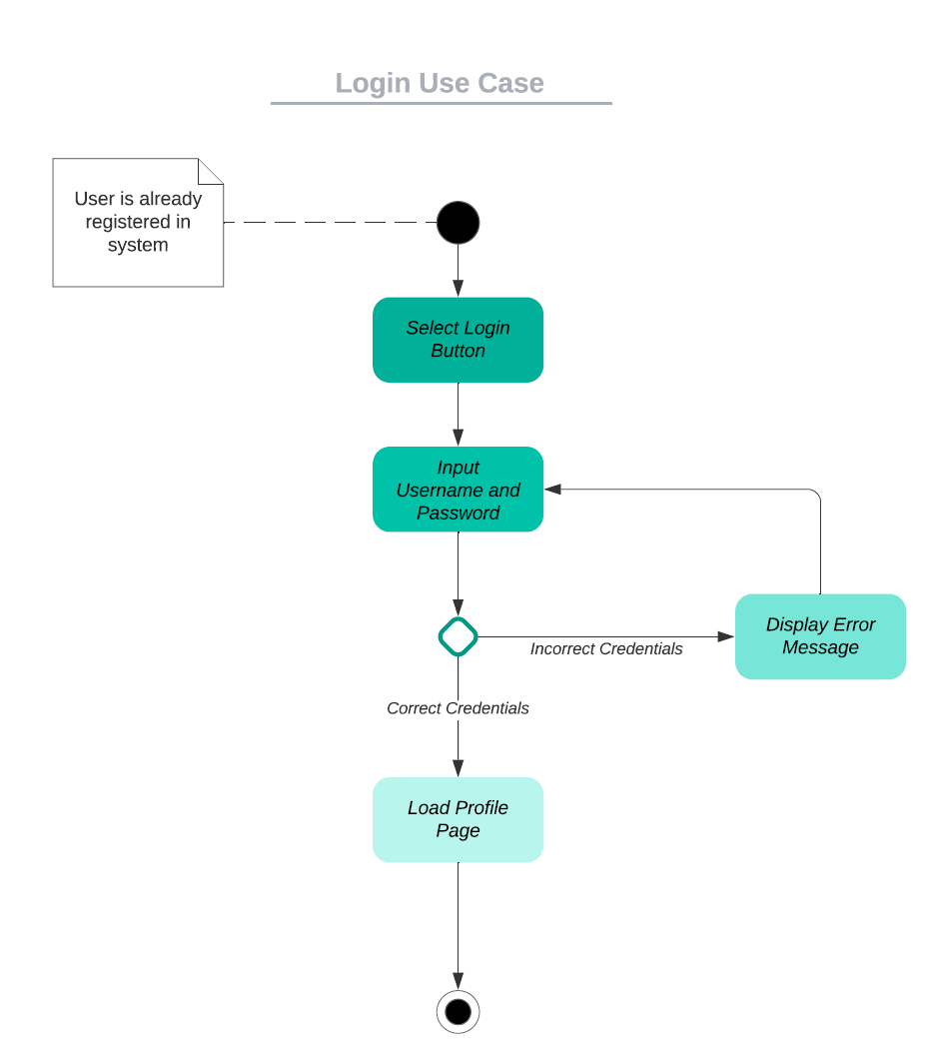

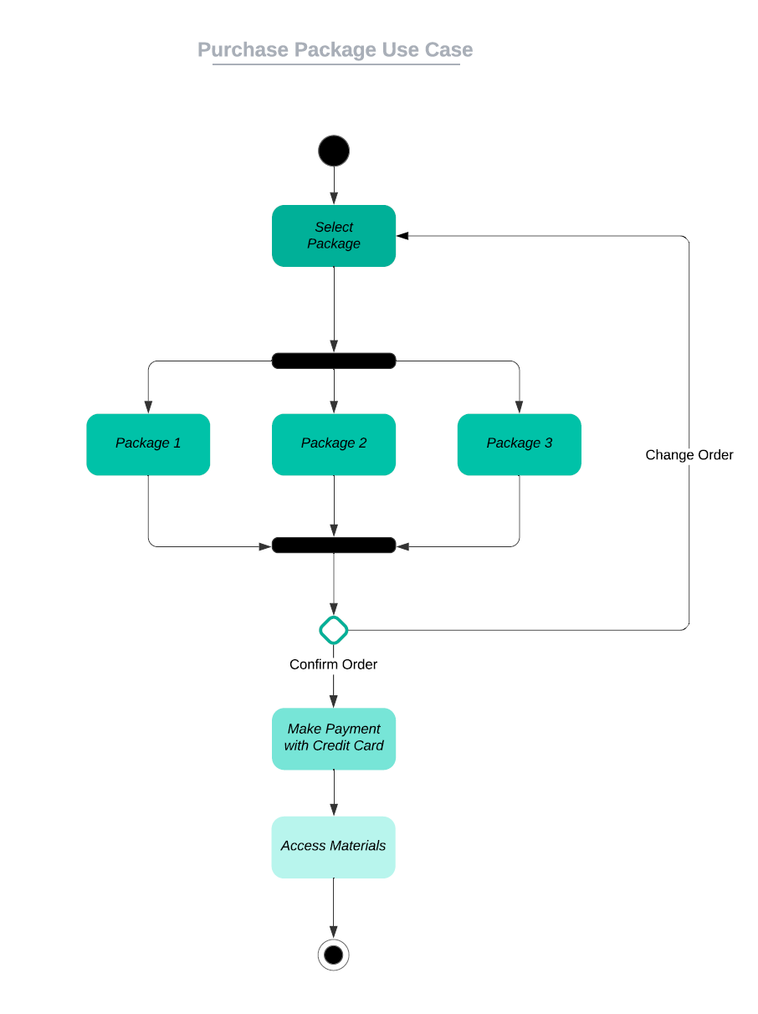

### UML Sequence Diagram

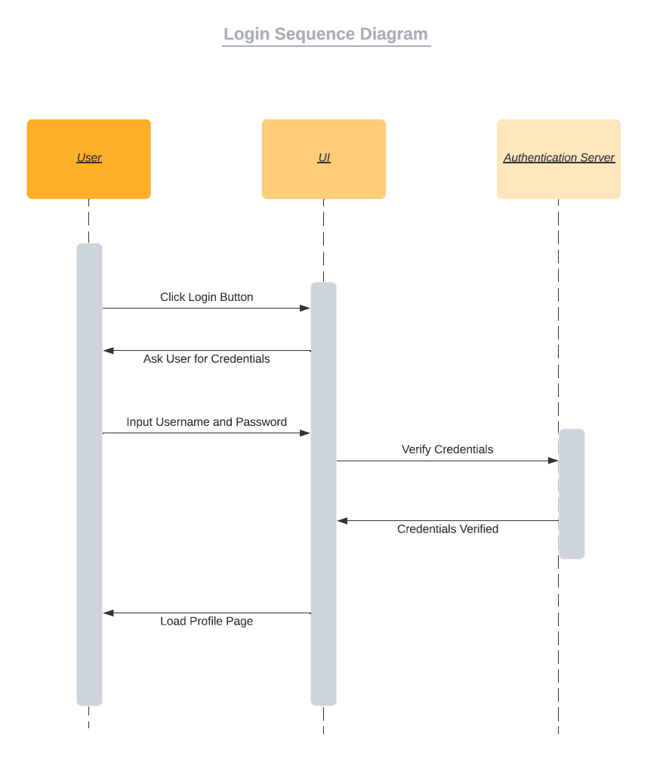

### UML Class Diagram

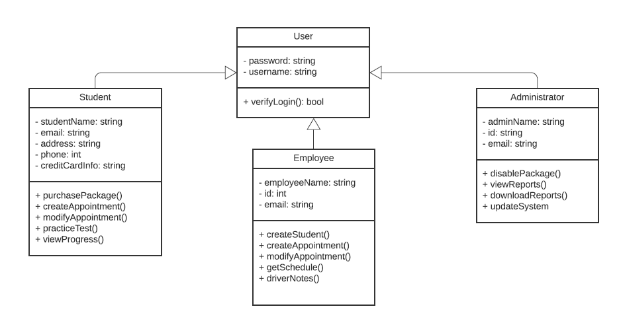

## Technical Requirements

For technical requirements, the system will be built in the cloud. This will also take care of any database and security needed as the cloud will support both of these. The database will be to hold any employee or student information. All data should be encrypted in order to protect personal information. For hardware, the system needs to be able to run on computers as well as mobile devices. The usual peripherals would also be necessary in this case (keyboard, mouse, monitor, etc.). Networking and routers will be needed to provide internet so users can access the system from their devices. For software, Windows, Apple and Android would be the main operating systems this will run on as well as the most common browsers like Edge, Chrome, Firefox and Safari.